**Autism Resources**

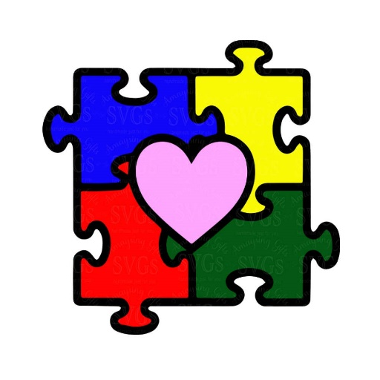

**Being a Friend**

<https://autism.sesamestreet.org/being-a-friend/>

**Seeing Amazing In All Children**

<https://autism.sesamestreet.org/>

**Guide for Grandparents**

<http://nationalautismassociation.org/guide-for-grandparents/>

**Parenting A Child With Autism**

<https://www.webmd.com/brain/autism/children-with-autism-coping-skills-for-parents#1>

**Autism Speaks-Parents**

<https://www.autismspeaks.org/parent>